Assignment 1

# Check no is even or odd.

Ans:-

# Algorithm-

* + 1. Start
    2. Get a input number
    3. Check whether it is odd or even using num%2==0
    4. If true, print even number. Else, print odd number
    5. Stop

# Flowchart:-

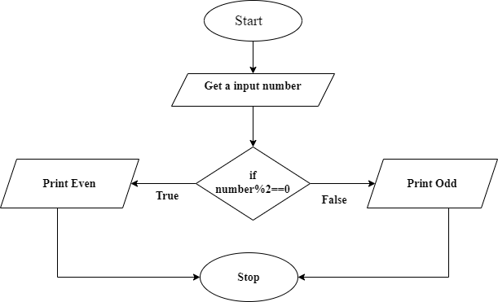

**Program** :

import java.util.Scanner; class EvenOdd{

public static void main(String args[]){

Scanner sc = new Scanner(System.in); System.out.print(" Enter any Numbers to check : "); int num = sc.nextInt();

if(num%2 == 0)

{

}

else

{

}

}

}

System.out.println(" Given number "+num+" is Even");

System.out.println(" Given number "+num+" is Odd");

**Output**:-

E:\cdac\assignments>javac EvenOdd.java E:\cdac\assignments>java EvenOdd Enter any Numbers to check : 34

Given number 34 is Even

E:\cdac\assignments>java EvenOdd Enter any Numbers to check : 33 Given number 33 is Odd

# Factorial of given number.

Ans- **Algorithm**:-

* + 1. Start
    2. Declare variable num, fact=1, i=1
    3. Get a input number
    4. Repeat until i<=num

Fact=fact*i i++

* + 1. Print factorial
    2. Stop

# Flowchart:-

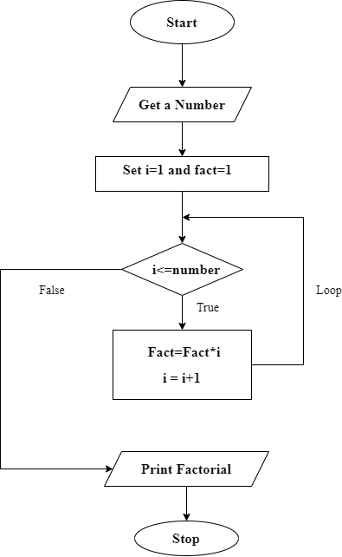

**Program** :

import java.util.Scanner; class Factorial

{

public static void main(String args[])

{

Scanner sc = new Scanner(System.in);

System.out.print(" Enter any Numbers to get Factorial : "); int num = sc.nextInt();

int fact=1; int i;

for(i=1;i<=num;i++)

{

fact=fact*i;

}

System.out.println("Factorial of "+num+" is "+fact);

}

}

**Output**:-

E:\cdac\assignments>javac Factorial.java E:\cdac\assignments>java Factorial Enter any Numbers to get Factorial : 5 Factorial of 5 is 120

E:\cdac\assignments>java Factorial Enter any Numbers to get Factorial : 4 Factorial of 4 is 24

# Factorial using recursion

Ans: **Algorithm**-

* + 1. Start
    2. Declare varible fact=1
    3. Get a number from user
    4. Call method facto(number) recursively until value of number>1
    5. Print factorial
    6. Stop

# Flowchart:

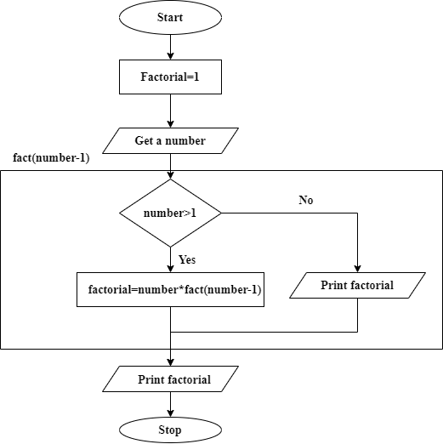

**Program**:- import java.util.*;

public class FactRec

{

public static void main(String[] args)

{

Scanner sc = new Scanner(System.in); System.out.print("Enter a number for factorial = "); int num=sc.nextInt();

long fact = facto(num);

System.out.println(" Factorial of " + num + " = " + fact);

}

public static long facto(int num)

{

if (num > 1)

return num * facto(num-1);

else

}

}

return 1;

# Output:-

E:\cdac\assignments>javac FactRec.java E:\cdac\assignments>java FactRec Enter a number for factorial = 3 Factorial of 3 = 6

E:\cdac\assignments>java FactRec Enter a number for factorial = 5 Factorial of 5 = 120

# Swap two numbers without using third variable.

Ans: **Algorithm**:-

* + 1. Start
    2. Get two numbers num1,num2
    3. Print unswap numbers

Num1=num1+num2 Num2=num1-num2 Num1=num1-num2

* + 1. Print swap numbers
    2. Stop

# Flowchart:-

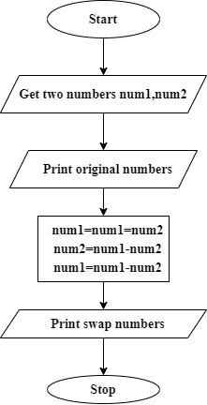

**Program**:

import java.util.Scanner; class SwapTwo

{

public static void main(String args[])

{

Scanner sc = new Scanner(System.in); System.out.println(" Enter two numbers to swap : "); int a = sc.nextInt();

int b = sc.nextInt();

System.out.println(" Before Swapping a = "+a+" b = "+b); a = a + b;

b = a - b;

a = a - b;

System.out.println(" After Swapping a = "+a+" b = "+b);

}

}

# Output:-

E:\cdac\assignments>javac SwapTwo.java E:\cdac\assignments>java SwapTwo Enter two numbers to swap : 34 65

Before Swapping a = 34 b = 65 After Swapping a = 65 b = 34

# Check given numbers whether it is positive or negative

Ans: **Algorithm**:

* + 1. Stop
    2. Get a number
    3. Check number%2==0 If true, print positive Else print negative
    4. Stop

# Flowchart:

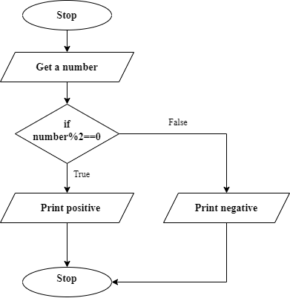

**Program:**

import java.util.Scanner; class Positive

{

public static void main(String args[])

{

Scanner sc = new Scanner(System.in); System.out.print(" Enter any Numbers to check : "); int num = sc.nextInt();

if(num > 0)

System.out.println(" Given number "+num+" is Positive");

else

}

}

System.out.println(" Given number "+num+" is Negative");

Output:-

E:\cdac\assignments>javac Positive.java E:\cdac\assignments>java Positive Enter any Numbers to check : 45

Given number 45 is Positive

E:\cdac\assignments>java Positive Enter any Numbers to check : -56 Given number -56 is Negative

# Leap year

Ans: **Algorithm**:-

1. Start
2. Get a input year
3. Check year divible by 4, if true go to step 4. else Go to step 7
4. Check year divisible by 100, if true go to step 5, else go to step 6
5. Check year divisible by 400, if true go to step 6, else go to step 7
6. Print leap year
7. Print not leap year
8. Stop

# Flowchart:-

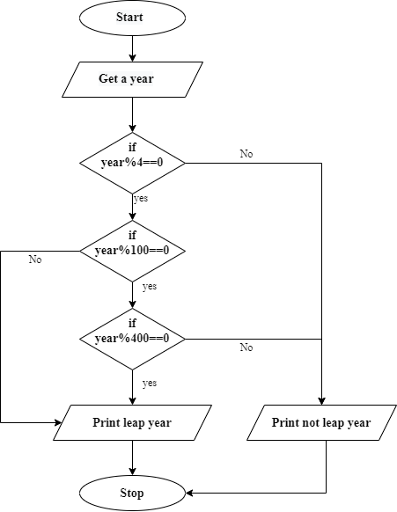

**Program**:-

import java.util.Scanner; class Leap

{

public static void main(String args[])

{

Scanner sc = new Scanner(System.in); System.out.print(" Enter any year to check : "); int yr = sc.nextInt();

if (((yr % 4 == 0) && (yr % 100!= 0)) || (yr%400 == 0))

System.out.println(yr+" year is a leap year");

else

}

}

System.out.println(yr+" year is not a leap year");

**Output**:- E:\cdac\assignments>java Leap Enter any year to check : 2020 2020 year is a leap year

E:\cdac\assignments>java Leap Enter any year to check : 2022 2022 year is not a leap year

# Print 1 to 10 without loop

Ans: **Algorithm**:-

1. Start
2. Call print metho
3. Define a method print

a. Check num<=10 if true print and

recursively call print method with num-1, else exit

1. Stop

# Flowchart:-

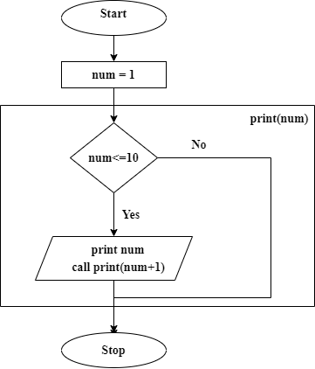

**Program**:

public class Print1to10

{

public static void main(String[] args)

{

printNum(1);

}

public static void printNum(int num)

{

if (num <= 10)

{

System.out.println(num); printNum(num+1);

}

}

}

**Output**:-

E:\cdac\assignments>javac Print1to10.java E:\cdac\assignments>java Print1to10

1 2 3 4 5 6 7 8 9 10

# Print the digit of given number.

Ans: **Algorithm**-

* + 1. Start
    2. Get a number
    3. Print the the value of number%10
    4. Number=number/10;
    5. Repeat step 3 to 4 until number is not equal to zero
    6. Stop

# Flowchart:-

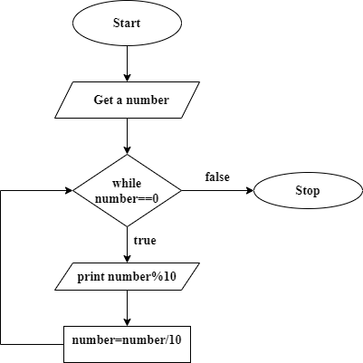

**Program**:-

import java.util.Scanner; class Digit

{

public static void main(String args[])

{

Scanner sc = new Scanner(System.in); System.out.println(" Enter any number "); int num = sc.nextInt();

while(num!=0)

{

System.out.println(num%10); num=num/10;

}

}

}

**Output**:-

E:\cdac\assignments>javac Digit.java

E:\cdac\assignments>java Digit Enter any number = 2356

Digits of number are = 6 5 3 2

# Factor of given number

Ans: **Algorithm**-

* + 1. Start
    2. Get a number
    3. Declare i=1
    4. Check number%i==0 if true print i and increment the valur of i
    5. Repeat step 4 until i<=number
    6. Stop

# Flowchart:-

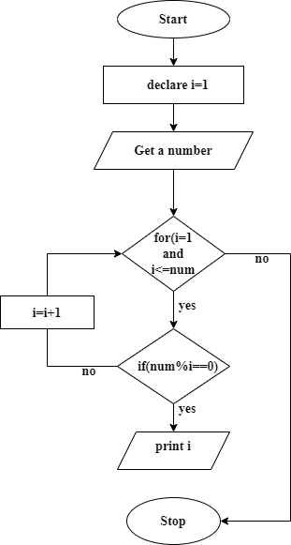

**Program:-**

import java.util.*; public class Factor

{

public static void main(String[] args)

{

System.out.print("Enter a number to get factors = "); Scanner sc=new Scanner(System.in);

int num = sc.nextInt();

System.out.print(" Factors of " + num + " are: "); for (int i = 1; i <= num; ++i)

{

if(num % i == 0)

{

System.out.print(i + " ");

}

}

}

}

# Output:-

E:\cdac\assignments>javac Factor.java E:\cdac\assignments>java Factor Enter a number to get factors = 45 Factors of 45 are: 1 3 5 9 15 45

# Sum of digit of given number

Ans: **Algorithm**:-

* + 1. Start
    2. Get a number
    3. Set sum=1
    4. While(number!=0)

Sum=sum+(number%10) Num=num/10

* + 1. Print sum
    2. Stop

# Flowchart:-

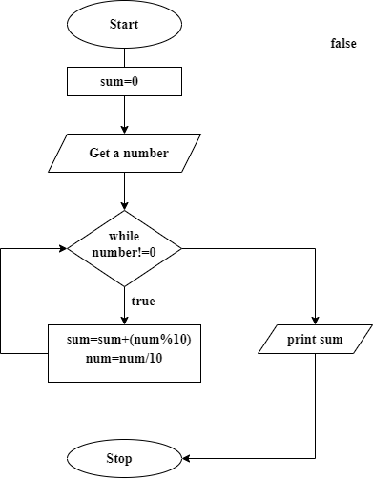

**Program**:-

import java.util.Scanner; class DigitSum

{

public static void main(String args[])

{

Scanner sc = new Scanner(System.in); System.out.println(" Enter any number "); int num = sc.nextInt();

int sum=0; while(num!=0)

{

sum=sum+(num%10); num=num/10;

}

System.out.println(" sum = "+sum);

}

}

**Output**:-

E:\cdac\assignments>javac DigitSum.java E:\cdac\assignments>java DigitSum Enter any number =5346

sum = 18

# Smallest of three numbers

Ans: **Algorithm**:-

1. Start
2. Get three numbers from user
3. Check if a<b and a<c, if true print a and exit else go to step 4
4. Check if b<a and b<c, if true print b and exit else go to step 5
5. Print c
6. Stop

# Flowchart:-

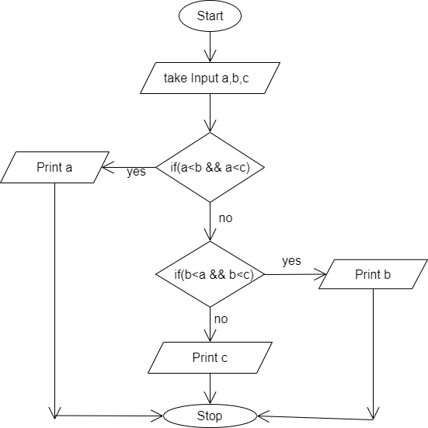

**Program**:-

import java.util.Scanner; class SmallThree

{

public static void main(String[] args)

{

Scanner sc = new Scanner(System.in);

System.out.print(" Enter Three Numbers to check Smallest : "); int a = sc.nextInt();

int b = sc.nextInt(); int c = sc.nextInt(); if(a<b && a<c)

{

System.out.println(a+" is the smallest number");

}else

if(b<a && b<c)

System.out.println(b+" is the smallest number");

else

}

}

System.out.println(c+" is the smallest number");

**Output**:-

E:\cdac\assignments>javac SmallThree.java E:\cdac\assignments>java SmallThree

Enter Three Numbers to check Smallest : 23 12 44 12 is the smallest number

# Addition without arithmetic operator

Ans: **Algorithm:-**

1. Start
2. Get two number
3. Call addNum(num1,num2) method 4. For(i=1;i<=num2;i++)

a. Num1++

1. Print Sum
2. Stop

# Flowchart:-

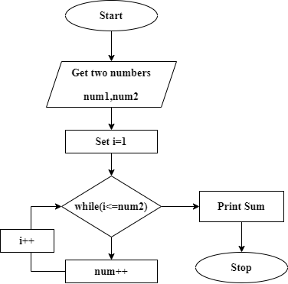

**Program:-**

import java.util.Scanner; class Add

{

public static void main(String[] args)

{

Scanner sc = new Scanner(System.in); System.out.print(" Enter first number = "); int num1 = sc.nextInt();

System.out.print(" Enter second number = "); int num2 = sc.nextInt();

int sum=addNum(num1,num2);

System.out.println("Sum of "+num1+" and "+num2+" = "+sum);

}

public static int addNum(int a, int b)

{

for(int i = 1; i <= b; i++) a++;

return a;

}

}

**Output:-** E:\cdac\assignments>javac Add.java E:\cdac\assignments>java Add Enter first number = 12

Enter second number = 23 Sum of 12 and 23 = 35

# Reverse a given number

Ans: **Algorithm**-

* + 1. Start
    2. Get a number
    3. Set rem=0, rev=0
    4. While(number!=0)
       1. int rem = num % 10
       2. rev = rev * 10 + rem
       3. num = num / 10
    5. Print rev
    6. Stop

# Flowchart:-

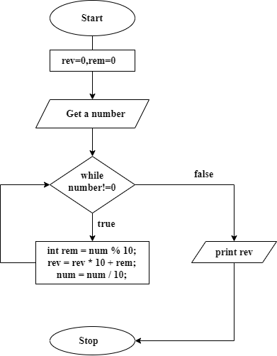

**Program**:-

import java.util.Scanner; class NumRev

{

public static void main(String[] args)

{

Scanner sc = new Scanner(System.in); System.out.print(" Enter any number to get reverse = "); int num = sc.nextInt();

int rev=0;

System.out.println(" Original Number: " + num); while(num != 0)

{

int rem = num % 10; rev = rev * 10 + rem; num = num / 10;

}

System.out.println(" Reversed Number: " + rev);

}

}

**Output**:-

E:\cdac\assignments>javac NumRev.java E:\cdac\assignments>java NumRev Enter any number to get reverse = 5645 Original Number: 5645

Reversed Number: 5465

# GCD of two number

Ans: **Algorithm**:-

* + 1. Start
    2. Get two number num1,num2
    3. Set gcd=1
    4. for(int i=1; i<= num1 && i<= num2; ++i) if(num1%i==0 && num2%i==0) set gcd=i
    5. Print GCD
    6. Stop

# Flowchart:-

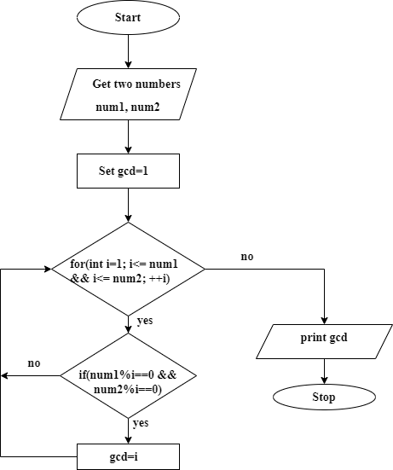

**Program**:-

import java.util.Scanner; class Gcd

{

public static void main(String[] args)

{

Scanner sc = new Scanner(System.in); System.out.print(" Enter first number = "); int num1 = sc.nextInt();

System.out.print(" Enter second number = "); int num2 = sc.nextInt();

int gcd = 1;

for(int i=1; i<= num1 && i<= num2; ++i)

{

if(num1%i==0 && num2%i==0) gcd = i;

}

System.out.println(" GCD of " + num1 +" and " + num2 + " = " + gcd);

}

}

**Output**:- E:\cdac\assignments>java Gcd Enter first number = 45

Enter second number = 18 GCD of 45 and 18 = 9

# LCM of two numbers

Ans: **Algorithm**:-

* + 1. Start
    2. Get two number num1,num2
    3. Set gcd=1
    4. for(int i=1; i<= num1 && i<= num2; ++i) if(num1%i==0 && num2%i==0) set gcd=i
    5. lcm=(num1*num2)/gcd
    6. print LCM
    7. Stop

# Flowchart:-

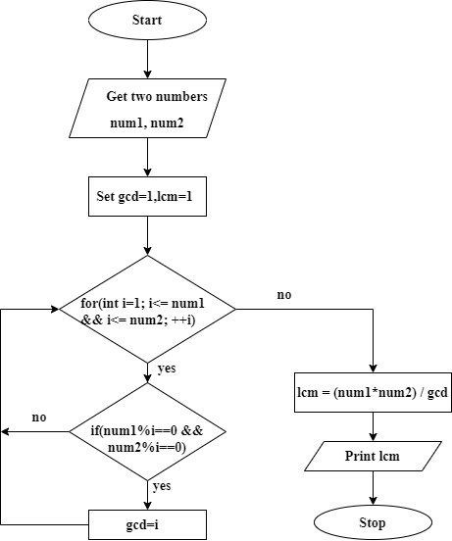

**Program:-**

import java.util.Scanner;

class Lcm

{

public static void main(String[] args)

{

Scanner sc = new Scanner(System.in); System.out.print(" Enter first number = "); int num1 = sc.nextInt();

System.out.print(" Enter second number = "); int num2 = sc.nextInt();

int gcd = 1;

for(int i=1; i<= num1 && i<= num2; ++i)

{

if(num1%i==0 && num2%i==0) gcd = i;

}

int lcm = (num1*num2) / gcd;

System.out.println("The LCM of "+num1+" and "+num2+" is "+lcm);

}

}

**Output**:- E:\cdac\assignments>java Lcm Enter first number = 45

Enter second number = 18 The LCM of 45 and 18 is 90

# Check Palindrome number or not.

Ans: **Algorithm**:-

1. Start
2. Get a number
3. Set reverse=0 and reminder=0
4. Set original=number
5. Check number!=0 if true go to 5 else goto 7
6. rem = num % 10; rev = rev * 10 + rem; num /= 10;
7. check if original==number if true print palindrome else print not palindrome
8. stop

# Flowchart:-

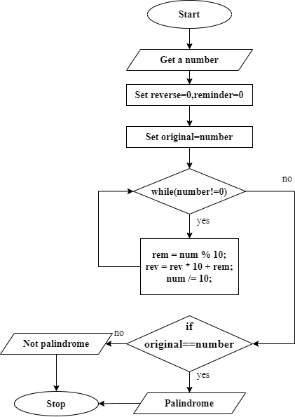

**Program**:-

import java.util.Scanner; class Palindrome

{

public static void main(String[] args)

{

Scanner sc = new Scanner(System.in); System.out.print(" Enter any number = "); int num = sc.nextInt();

int rev = 0, rem; int original = num; while (num != 0)

{

rem = num % 10; rev = rev * 10 + rem; num /= 10;

}

if (original == rev)

{

}

else

{

}

System.out.println(original + " is Palindrome.");

System.out.println(original + " is not Palindrome.");

}

}

**Output**:-

E:\cdac\assignments>java Palindrome Enter any number = 12321

12321 is Palindrome.

E:\cdac\assignments>java Palindrome Enter any number = 3456

3456 is not Palindrome.

# Prime Factor of given number

Ans: **Algorithm**:-

* + 1. Start
    2. Enter the Number.
    3. Take i=2.
    4. Check the Input Number is greater than Then enter in loop.
       1. while(Number is greater than 1)
       2. Check the condn if(Number%i==0)
       3. if it is true enter in bracket.
       4. print(i) value on terminal
       5. Number=Number/I else i++ then loop will iteration again
    5. Stop

# Flowchart-

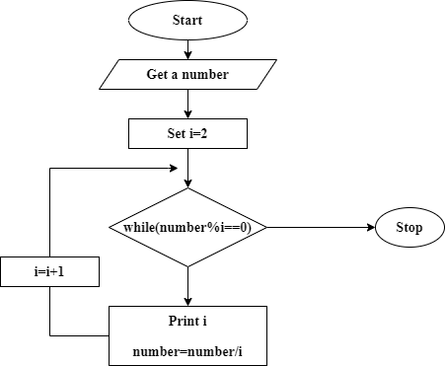

**Program:-**

import java.util.Scanner; public class PrimeFactor

{

public static void main(String args[])

{

int number;

Scanner sc = new Scanner(System.in); System.out.print("Enter a number ="); number = sc.nextInt();

for(int i = 2; i<=number; i++)

{

while(number%i == 0)

{

System.out.println(i+" "); number = number/i;

}

}

}

}

**Output**:-

E:\cdac\assignments>java PrimeFactor Enter a number =30

2 3 5

E:\cdac\assignments>java PrimeFactor Enter a number =28

2 2 7

# Even series

Ans: **Algorithm**:-

* + 1. Start
    2. Get a number from user upto which they want to print even number
    3. Set i=2
    4. If i<=number, print i and i=i+2. Else go to step 6
    5. Repeat step 4 until i<=number
    6. Stop

# Flowchart:-

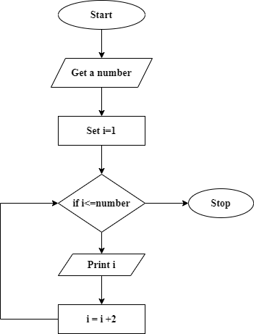

**Program** :-

import java.util.Scanner; class EvenSeries

{

public static void main(String args[])

{

Scanner sc = new Scanner(System.in);

System.out.print(" Enter Numbers upto which you want to print even no : "); int num = sc.nextInt();

for(int i=2; i<=num; i=i+2)

{

if(i%2 == 0)

{

System.out.println(i);

}

}

}

}

**Output**:-

E:\cdac\assignments>javac EvenSeries.java E:\cdac\assignments>java EvenSeries

Enter Numbers upto which you want to print even no : 15 2 4 6 8 10 12 14

# odd series

Ans: **Algorithm**:-

* + 1. Start
    2. Get a number from user upto which they want to print even number
    3. Set i=1
    4. If i<=number, print i and i=i+2. Else go to step 6
    5. Repeat step 4 until i<=number
    6. Stop

# Flowchart:-



**Program** :-

import java.util.Scanner; class OddSeries

{

public static void main(String args[])

{

Scanner sc = new Scanner(System.in);

System.out.print(" Enter Numbers upto which you want to print even no : "); int num = sc.nextInt();

for(int i=1; i<=num; i++ )

{

if(i%2 != 0)

{

System.out.println(i);

}

}

}

}

**Output**:-

E:\cdac\assignments>javac OddSeries.java E:\cdac\assignments>java OddSeries

Enter Numbers upto which you want to print even no : 15 s1 3 5 7 9 11 13 15